University of Utah
School of Computing
CS 6967: Security Operations

Name: Syeda Mishra Saiara
uID: u1457424

Lab 11 Response Outline

Lab 11: Threat Hunting with Memory Dump
Test 1: Capture a Memory Dump
Summary of test experience:
This lab is about working with memory dump from a victim windows machine and using volatile to do forensics on memory dumps. As a preparation step, I installed Volatility3 in my Kali Linux VM. And downloaded Winpmem in my windows VM. The first test is to capture the memory by executing Winpmem on windows and transferring that .raw file to Kali Linux VM. To do so, I ran the command .\winpmem_mini_x64_rc2.exe memdump.raw in powershell at the directory where the winpmem was downloaded. It created a memory image in the file “memdump.raw”.
Screenshot of test results:
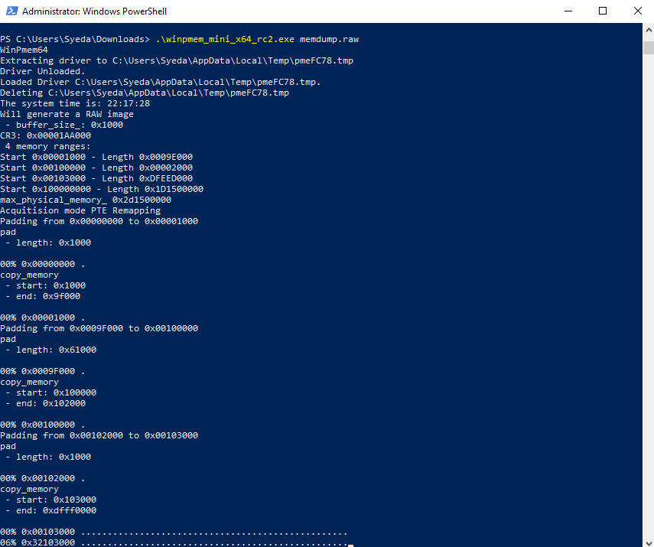
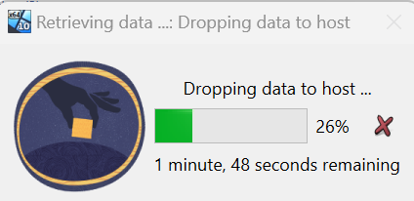
How does the image demonstrate that you completed the test?
The information in the first screenshot shows that it is creating an image of the memory by unloading the drivers and copying memory into the file.

Test 2: Identify OS Information
Summary of test experience:
After transferring the memdump.raw file, which consists of the memory images of the windows system to the kali linux VM, I navigated to the directory where Volatility3 was installed, and then ran the command python vol.py -f /home/kali/memdump.raw windows.info. This was to extract the OS information of the memory image that I have transferred in my Kali Linux.
Screenshot of test results:
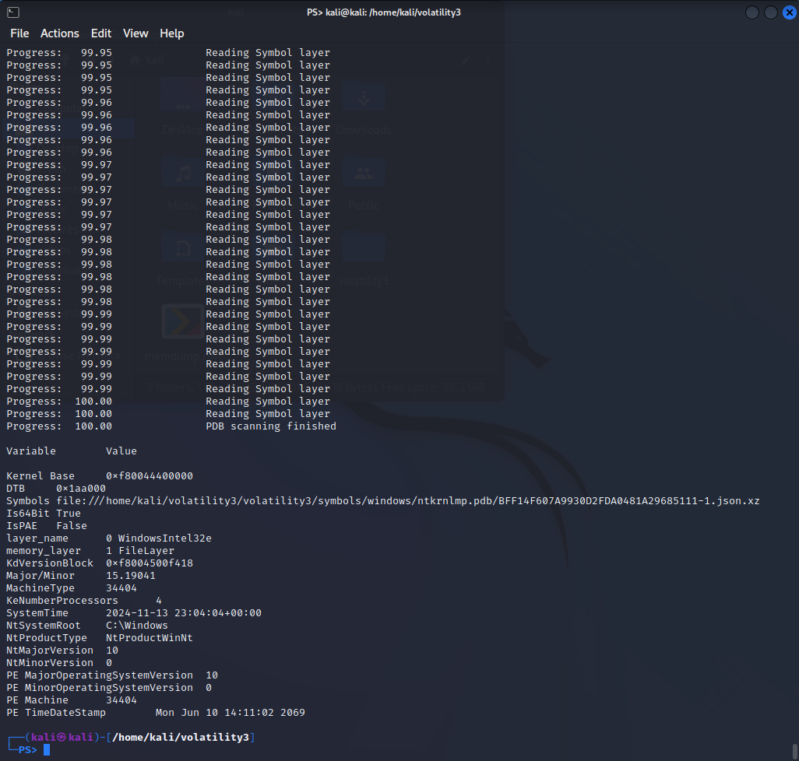

How does the image demonstrate that you completed the test?
The information about the system, kernel and memory designs are shown after the processing is done. As shown in the screenshot, it gave indications about the memory being of a windows operating system. The system root information, memory layer name etc. confirmed that.

Test 3: List the Running Processes
Summary of test experience:
Now that we have the information about the OS the next task was to list the running processes in that memory dump. For that, I ran the command python vol.py -f /home/kali/memdump.raw windows.pslist.PsList in the same terminal.
Screenshot of test results:
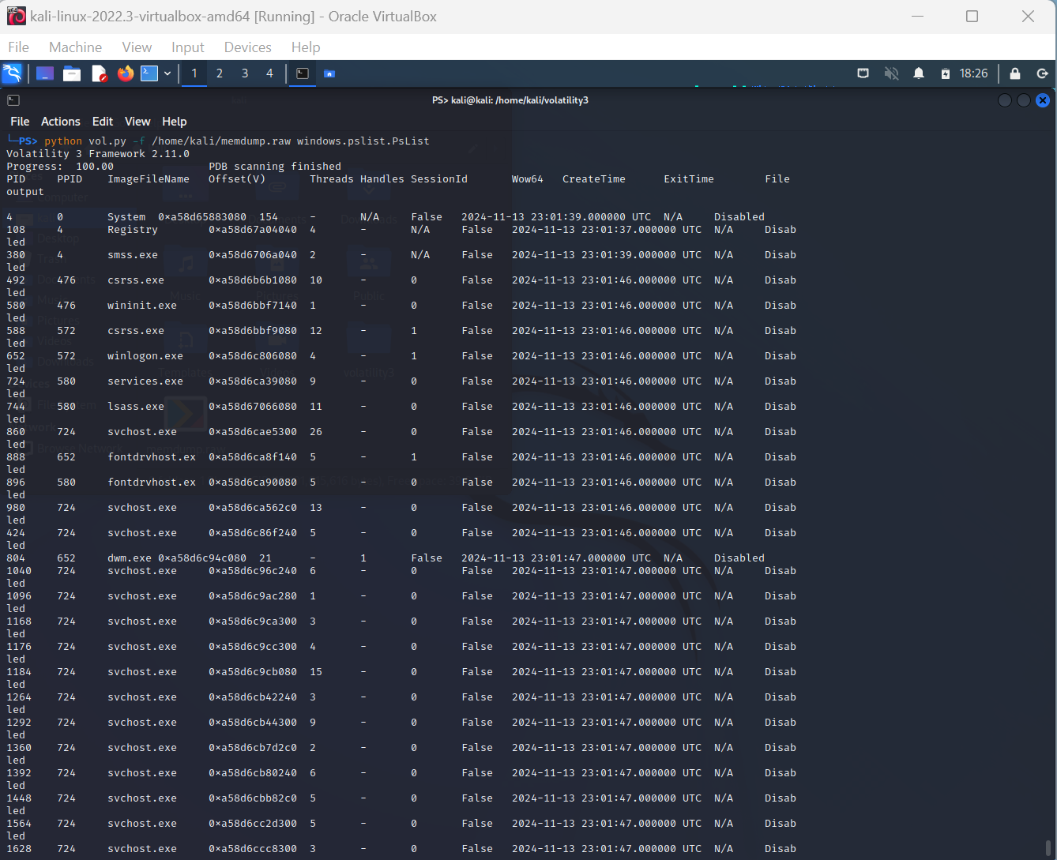
How does the image demonstrate that you completed the test?
As shown in the screenshot, there are process IDs, process names, thread counts and names of the systems running in those processes after extracting the process information from the memory dump.

Test 4: List Network Connections
Summary of test experience:
The next step of this memory information extraction was to know about the network connections in that memory dump. To do so, I ran the command, python vol.py -f /home/kali/memdump.raw windows.netscan.NetScan in the same terminal.

Screenshot of test results:
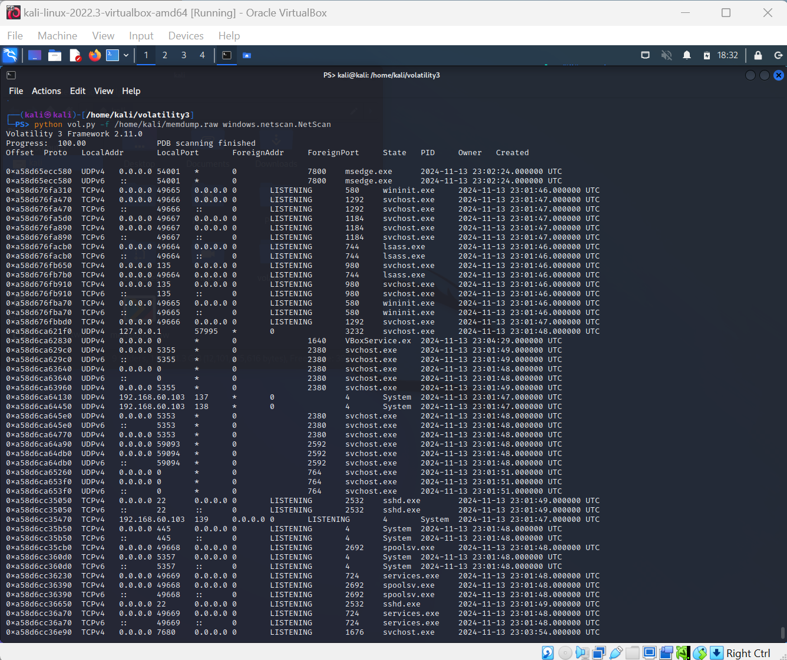

How does the image demonstrate that you completed the test?
The screenshot shows the information about the network connections made by the windows system all along. There is information about network protocols, the source IP addresses and the targeted IP addresses along with the states in that connection and the time of that connection too.

Test 5: Establish Reverse Shell on the Windows VM
Summary of test experience:
Now that we had a pretty good idea how we can explore different sides of the memory thing, the next task was about figuring those out for a malicious activity in the windows system. To start that, at first, there needed to be a remote shell attack on the windows system by downloading a reverse shell script on the windows system. After doing the changes mentioned in the instructions, I ran the command nc -lvp 1234 in my kali linux terminal. And then, I ran the command powershell -ep Bypass \path\to\mini-reverse.ps1 through my powershell not as an administrator but as a user. (Mentioning it because I did the first time as an admin and then there was a big hang and relative errors for some reason.)
After completing the steps, I ran dir command in my kali linux which was trying to build a remote connection to the windows system.
Screenshot of test results:
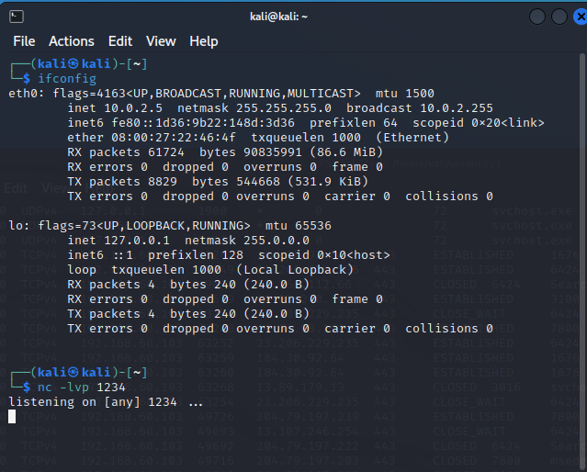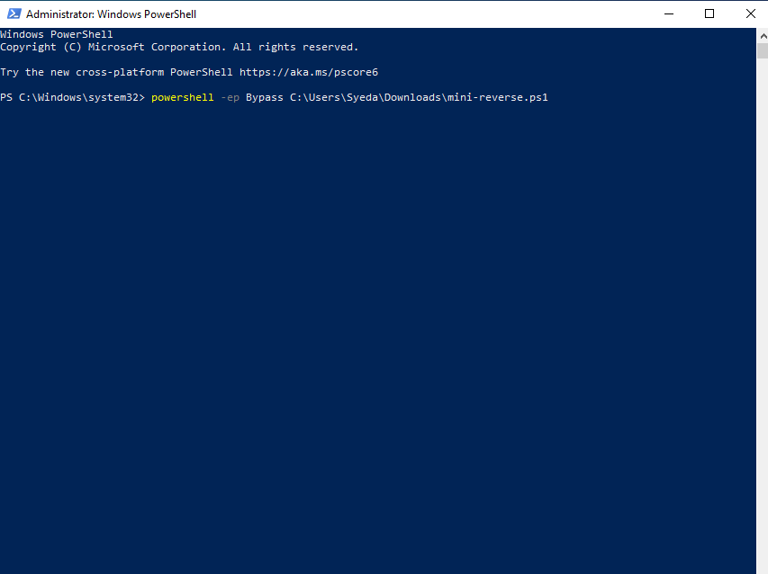
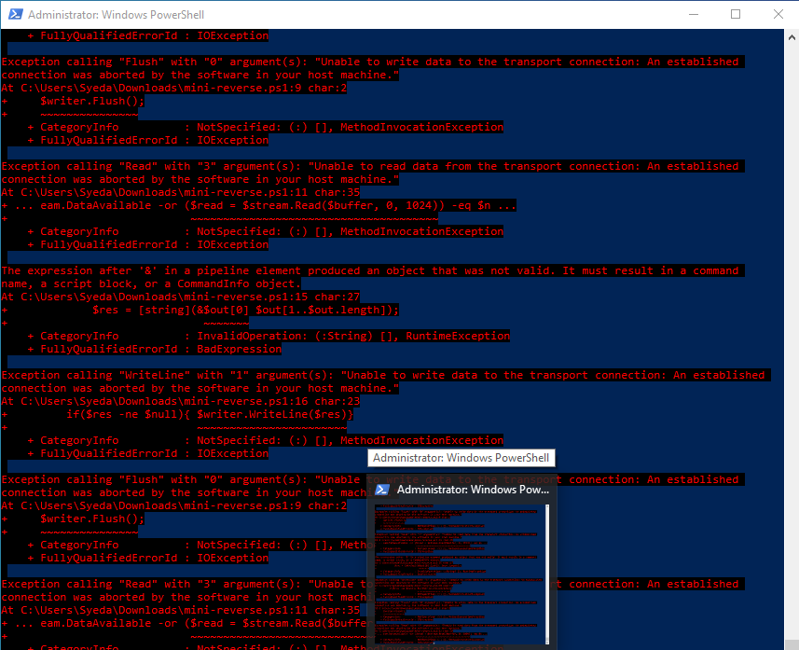
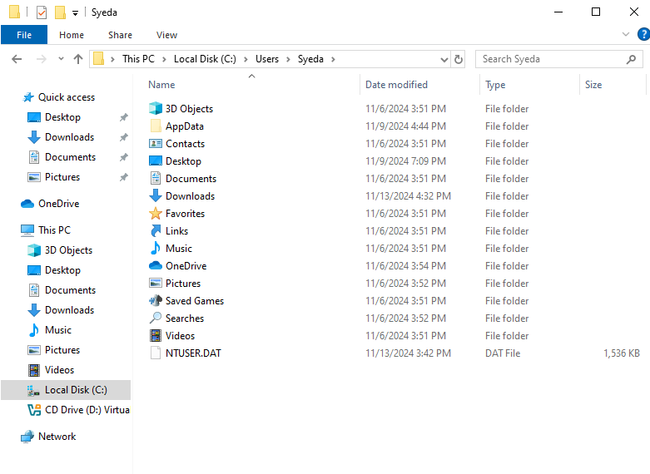
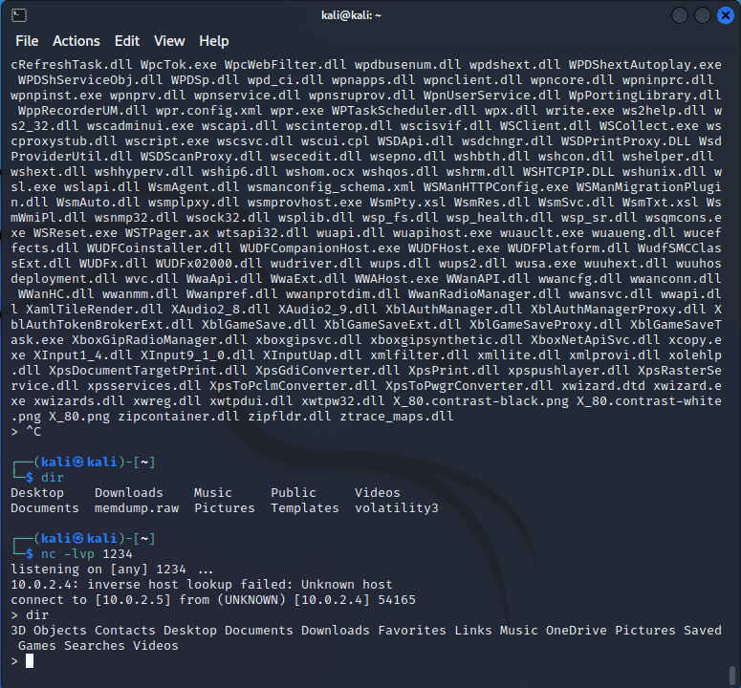
How does the image demonstrate that you completed the test?
The last screenshot showed that, when the connection was made and directory information was tried to be accessed, the folder directories of the windows system were shown in the Kali Linux terminal.

Test 6: Find Abnormal Network Connections
Summary of test experience:
After this malicious activity, there was a memory dumping again done on the windows system, and then transferred just like before to the Kali Linux system.
Screenshot of test results:
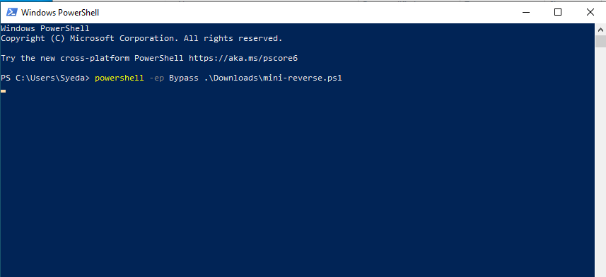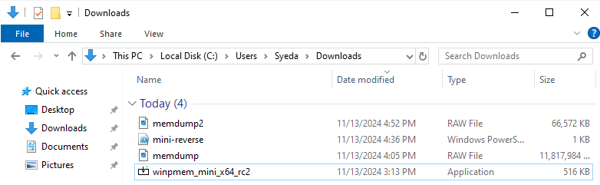
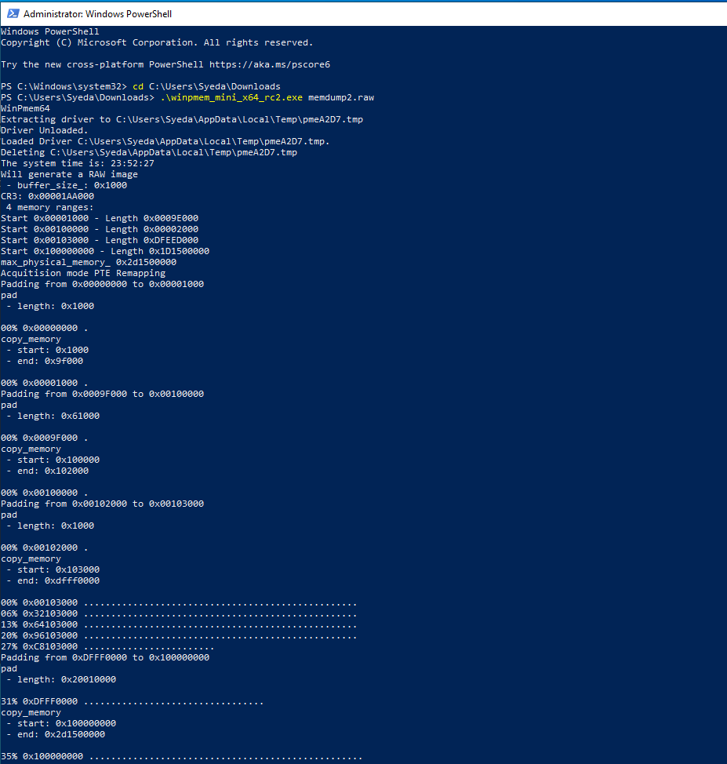
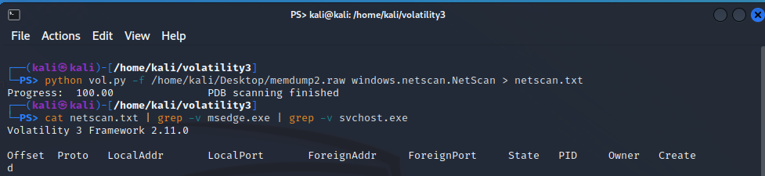
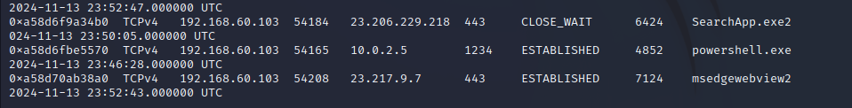
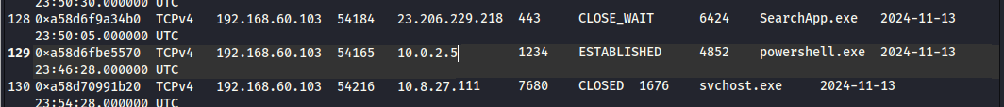

How does the image demonstrate that you completed the test?
The results indicated a network established through powershell into Kali Linux system through the port and IP address manipulated in the mini reverse script.

